PLASMA DONOR APPLICATION PROJECT REPORT

# TEAMID:PNT2022TMID28121

1. **INTRODUCTION**

## Project Overview

A plasma is a liquid portion of the blood, over 55% of human blood is plasma. Plasma is used to treat various infectious diseases and it is one of the oldest methods known as plasma therapy. Plasma therapy is a process where blood is donated by recovered patients in order to establish antibodies that fight the infection. In this project plasma donor application is being developed by using AWS services. The services used are AWS Lambda, API gateway, DynamoDB, AWS Elastic Compute Cloud with the help of these AWS services, it eliminates the need of configuring the servers and reduces the infrastructural costs associated with it and helps to achieve server less computing. For instance, during COVID 19 crisis the requirement for plasma increased drastically as there was no vaccination found in order to treat the infected patients, with plasma therapy the recovery rates were high but the donor count was very low and in such situations it was very important to get the information about the plasma donors. Saving the donor information and notifying about the current donors would be a helping hand as it can save time and help the users to track down the necessary information about the donors.

## Purpose

As we all know, the traditional methods of finding plasma, one has to find out for oneself by looking at hospital records and contacting donors have been recovered, sometimes may not be available at home and move to other places. In this type of scenario, the health of those who are sick becomes disastrous. Therefore, it is not considered a rapid process to find plasma. The main purpose

of the proposed system, the donor who wants to donate plasma can simply upload their covid19 traced certificate and can donate the plasma to the blood bank, the blood bank can apply for the donor and once the donor has accepted the request, the blood bank can add the units they need and the hospital can also send the request to the blood bank that urgently needs the plasma for the patient and can take the plasma from the blood bank.

# LITERATURE SURVEY

## Existing problem

There are many people who are willing to donate plasma and who need plasma. But there is not any accessible way to help them to find plasma donation centers in real- time. So, the problem is not the lack of donors, but finding the right sponsor at the right time. If someone needs plasma, they seek plasma first from family members, then from hospitals and the nearest plasma bank. If they can't process plasma in these ways, it's very difficult for them to contact another for a short-term plasma draw. This is a problem that I want to solve through this application. Instead of just providing plasma to people in need with an outdated list of regular plasma donors who may or may not be available to help, This application reaches the right people the moment users find Out.

# References

* + 1. **BLOODR: blood donor and requester mobile application**

## Author: [Vamsi Krishna Tatikonda a](https://pubmed.ncbi.nlm.nih.gov/?term=Tatikonda%20VK%5BAuthor%5D)nd [Hosam El-Ocla](https://pubmed.ncbi.nlm.nih.gov/?term=El-Ocla%20H%5BAuthor%5D)

Donors can be individuals and blood banks. Donor users can register to the application to receive notification about blood donation requests when their blood type is required for an admitted patient to a clinic. In the online registration, users need to provide information about their blood type and address. Once the user login, he would be able to see the latest blood donation requests in their city/region using “Blood Requests Feed”. Each notification contains information about the required blood type and the clinic address

together with a request status as pending if the donation is not done yet. If someone has donated, then the request status is marked as success so that potential donors would receive an updated notification indicating that the blood donation has been made and there is no further donation is required for this particular request. Blood donation has a significant impact on iron stores in frequent donors, particularly females. Several measures are necessary to prevent, detect, and treat iron deficiency in donors. These include less frequent donations by donors most susceptible to iron deficiency, and better education of both donors and their physicians about iron needs associated with blood donation. Regular blood donors may require a course of iron supplements to replenish the iron lost in blood donation. These individuals can often return to blood donation, after an adequate course of iron supplementation [(17)](https://www.ncbi.nlm.nih.gov/pmc/articles/PMC5682362/#r17). As a result, donor may track his/her donation history details using “Donation History” to avoid such risky intensive donations before that the body can makeup its lost red blood cells. Donors can invite friends to register to the application using “Invite Friends” to increase the number of donors. When a donor is notified about a blood request, he/she can book an appointment with the clinic that requested the donation using the “Book Appointment feature”.

# Blood component

## Author: Denuis O'Neil (1999)

The Amount of human body weight comes from blood. For adults, it is 4-6 litres of blood. This essential liquid plays an important role in transporting oxygen and nutrients to cells and removing carbon dioxide, ammonia and other waste products. Blood is a very common tissue composed of over 4000 different types of components.

# COPAL-19: Plasma Donor App

## source : [News Desk-07/09/2020](https://www.geospatialworld.net/author/gmcnewsdesk/)

Doctors of AIIMS with the help of IIT Delhi students have developed an app called COPAL-19 to track real- time COVID-19 patients in AIIMS, as they can become potential plasma donors after 28 days of recovery. The app will have details of patients who have already been discharged from AIIMS, those currently undergoing treatment and their blood groups. This information will help patients in need of plasma therapy to get it on time without any hassle. Once the app goes live, anyone will be able to register as a plasma donor by simply downloading the app and filling in the details in a simple format. AIIMS blood bank is also linked with the app so they will also get the details of the needy patient and help him/her get the plasma. Patients can also register themselves and get details of plasma donors matching their blood group.

# 4.A Free Health Screening

## Author: Dr. DeSimone

Before you are allowed to donate, your vital signs will be checked to make sure you are fit enough for the procedure. This exam might turn up a condition that needs medical attention, such as high blood pressure or a heart arrhythmia like atrial fibrillation. In addition, you’ll be screened for infectious diseases you may be unaware of.

“If we detect an issue with your vital signs or another health issue, we would direct you to go to a physician at that point to be checked,” Dr. DeSimone says. The health screening will also reveal if you have a rare blood type. This information can be useful if you ever face surgery or another medical situation in which a transfusion may required. Plus, you’ll have the satisfaction of knowing your donation is particularly needed.

**5. How to Motivate Whole Blood Donors to Become Plasma Donors Author: Gaston Godin and Marc Germain**

This study tested the efficacy of interventions to recruit new plasma donors among whole blood donors. A sample of 924 donors was randomized to one of three conditions: control; information only by nurse; and information plus self- positive image message by nurse (SPI). Participants in the control condition only received a leaflet describing the plasma donation procedure. In the two experimental conditions the leaflet was explained face-to-face by a nurse. The dependent variables were the proportion of new plasma donors and the number of donations at six months. Overall, 141 (15.3%) new plasma donors were recruited at six months. There were higher proportions of new plasma donors in the two experimental conditions compared to the control condition (); the two experimental conditions did not differ. Also, compared to the control condition, those in the experimental conditions (all) gave plasma more often (information only by nurse: ; SPI: ); the SPI intervention significantly outperformed () the information only by nurse condition. The results suggest that references to feelings of SPI such as feeling good and being proud and that giving plasma is a rewarding personal experience favour a higher frequency of plasma donation.

# Problem Statement Definition

This system aims at connecting the donors & the patients by an online application. By using this application, the users can either raise a request for plasma donation or requirement. Similar to blood donors there also exist plasma donors where there exists problems like in case of emergency needs the most important life saver necessity is plasma. Plasma Banks are the main providers of plasma who receives blood from various donors, monitors the plasma groups database of emergencies and makes them available to the hospital whenever needed. The major problem faced by the main plasma providers and the need is the availability of donors at the right time. We hereby took a step forward to build a system to create a network of people who can help each other in need. We propose an application where the plasma banks can timely update the plasma Stock availability and donor and register themselves to the donor and the user

can find plasma availability nearby him/her. The urgent time of a plasma requirement, users can quickly check for plasma banks, hospitals or donors as per requirement matching a particular or related and reach out to them through the App.

# IDEATION & PROPOSED SOLUTION

## Empathy Map Canvas

An empathy map is a simple, easy-to-digest visual that captures knowledge about a user’s behaviour and attitudes. It is a useful tool to helps teams better understand their users. Creating an effective solution requires understanding the true problem and the person who is experiencing it. The exercise of creating the map helps participants consider things from the user’s perspective along with his or her goals and challenges.

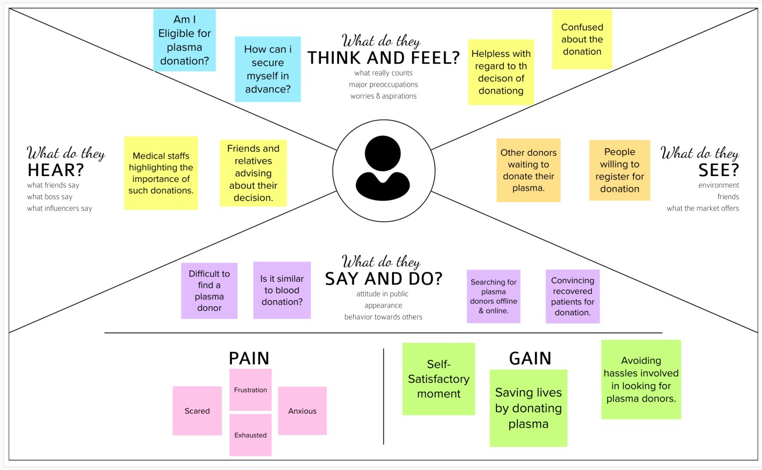

# Ideation & Brainstorming

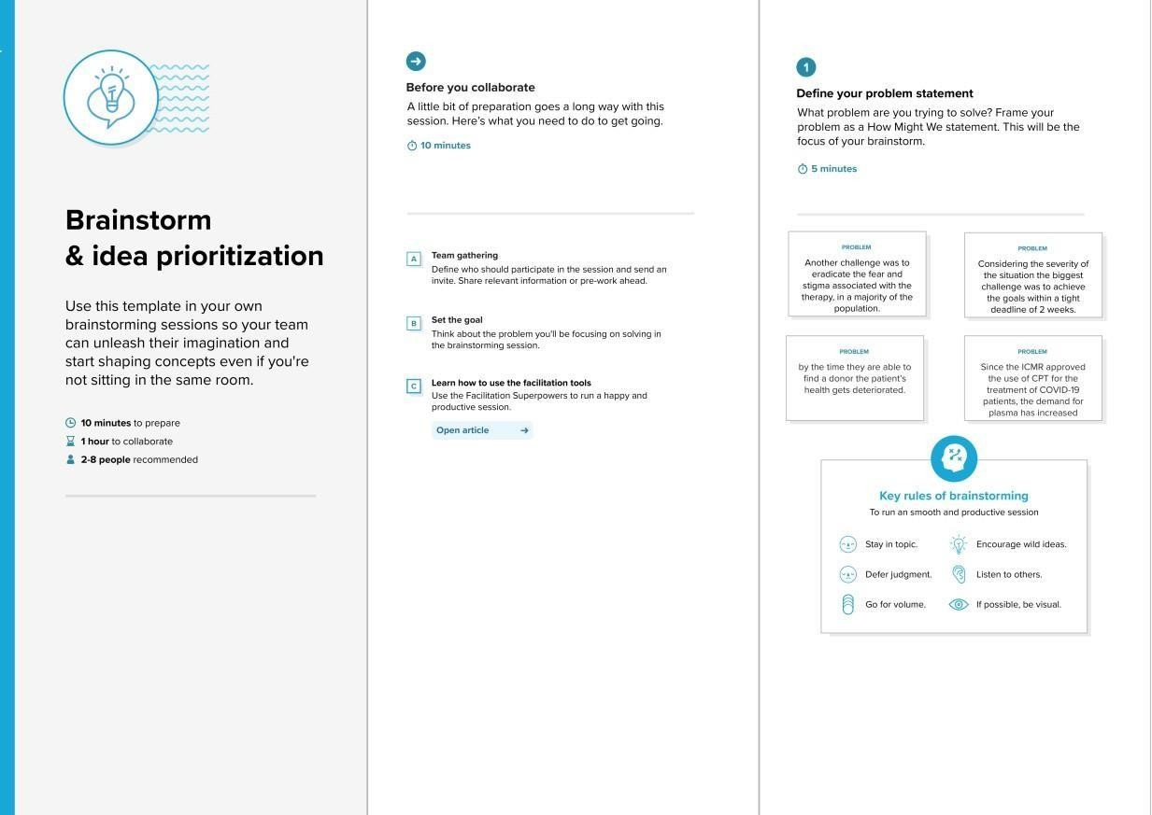

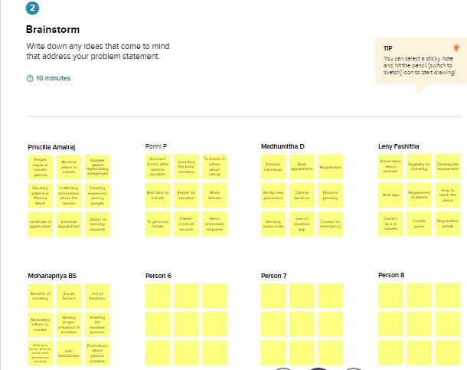

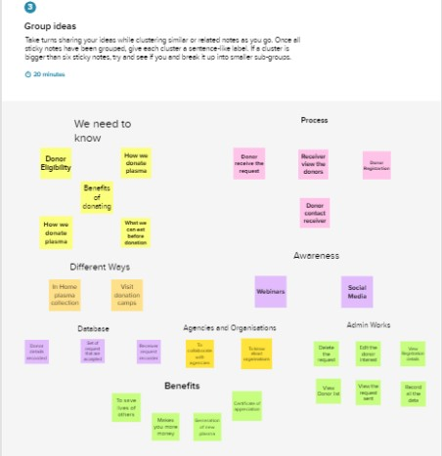

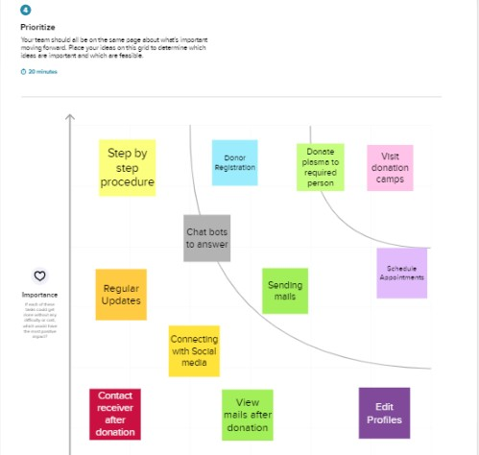

* 1. **Proposed Solution**

|  |  |  |
| --- | --- | --- |
| 1. | Problem Statement (Problem to be solved) | People who need plasma are increasing day by day. People who have diseases like multiple myeloma (type of cancer) or plasmacytoma need constant supply of plasma to sustain their life and there is not enough plasma available for them. It is important for the people who are excited to donate, but yet are very busy, to be sure where and when they can donate, and therefore we are designing a system which saves the information of the registered donors and notifies about the current donors and help the users to track down the necessary information  about the donors at the time of their need. |

|  |  |  |
| --- | --- | --- |
| 2. | Idea / Solution description | The app which is going to be developed and implemented,   * Provides space for the patients in need of plasma to get the required amount of plasma units on request. The patient has to register in the app and place request at the time of their need. * It also acts as a platform for people who are interested in donating plasma. The donors can register themselves. |
| 3. | Novelty / Uniqueness | The uniqueness and working of this app is helpful in saving many lives. This app can be installed in mobile phones and register using their mail id or phone number. Patients in need of plasma and individuals willing to donate can make use of this app and get benefitted. It is accessible to everyone and anywhere. |
| 4. | Social Impact / Customer Satisfaction | Plasma donation being not so popular in the society as much as blood donation is. It is not that people do not want to and are not willing to donate blood and plasma, but because they have no idea where they can donate and also that people are not aware of the importance of blood and plasma donation. There is a need for  spreading |
|  |  | awareness among the people and the importance of plasma donation. |

|  |  |  |
| --- | --- | --- |
| 5. | Business Model (Revenue Model) | The app going to be developed is made available to all and accessible. This app helps reach people in search of plasma and people willing to donate can also use this app. The user interface is made simple so that everyone can use it without any hassle. |
| 6. | Scalability of the Solution | This app enables plasma requiring people to get their plasma from anywhere. They will have to register and request at the time of need.  According to the availability of donors, the receivers will be notified and the donors also will be notified about the request. |

* 1. **Problem Solution fit**

The Problem-Solution Fit simply means that you have found a problem with your customer and that the solution you have realized for it actually solves the customer’s problem. It helps entrepreneurs, marketers and corporate innovators identify behavioral patterns and recognize what would work and why **Purpose:**

* + - Solve complex problems in a way that fits the state of your customers.
    - Succeed faster and increase your solution adoption by tapping into existing mediums and channels of behavior.
    - Sharpen your communication and marketing strategy with the right triggers and messaging.
    - Increase touch-points with your company by finding the right problem-behavior fit and building trust by solving frequent annoyances, or urgent or costly problems.
    - Understand the existing situation in order to improve it for your target group.

**Template:**

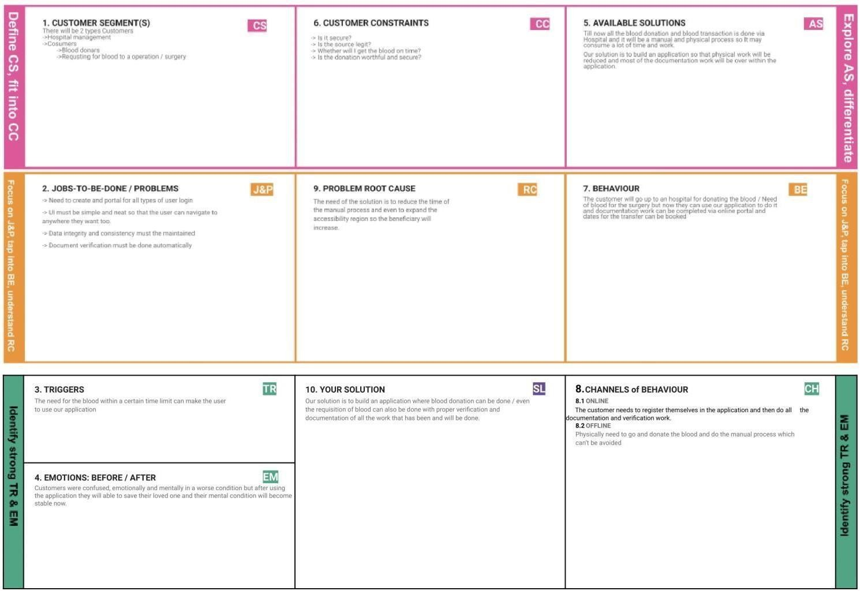

1. **REQUIREMENT ANALYSIS**

## 4.1.Functional requirement

Following are the functional requirements of the proposed solution.

|  |  |  |
| --- | --- | --- |
| **FR No.** | **Functional Requirement (Epic)** | **Sub Requirement (Story / Sub-Task)** |
| FR-1 | User Registration | Registration through Website |
| FR-2 | User Confirmation | Confirmation via Email |
| FR-3 | User Login | Login using Registered email Id |
| FR-4 | Sent Request | If plasma is required, the receiver will contact the donor |
| FR-5 | Contact Donor | Contact the donor directly if a phone number is given |
| FR-6 | View donation camps | View the list of donation camps happening nearby |

**4.2 Non-Functional requirement**

Following are the non-functional requirements of the proposed solution.

1. PROJECT DESIGN

|  |  |  |
| --- | --- | --- |
| **FR No.** | **Non-Functional Requirement** | **Description** |
| NFR-1 | **Usability** | The user interface of the plasma donor system must be well-designed and welcoming. |
| NFR-2 | **Security** | Data storage is required by security systems, just like it is by many other applications. Databases are able to keep all the donor information that is viewed by applications. It must be secured with email Id and  password. |
| NFR-3 | **Reliability** | The system has the ability to work all the times without failures apart from network failure. A donor can have the faith on the system. The authorities will keeps the privacy of all donors in a proper manner |
| NFR-4 | **Performance** | The Plasma donor System must perform well in different scenarios. The system is interactive and delays involved are less. |
| NFR-5 | **Availability** | The system, including the online components, should be available 24/7. |
| NFR-6 | **Scalability** | The system offers the proper resources for issue solutions and is designed to protect sensitive information during all phases of operation. |

# PROJECT DESIGN

* 1. **DATA FLOW DIAGRAM**

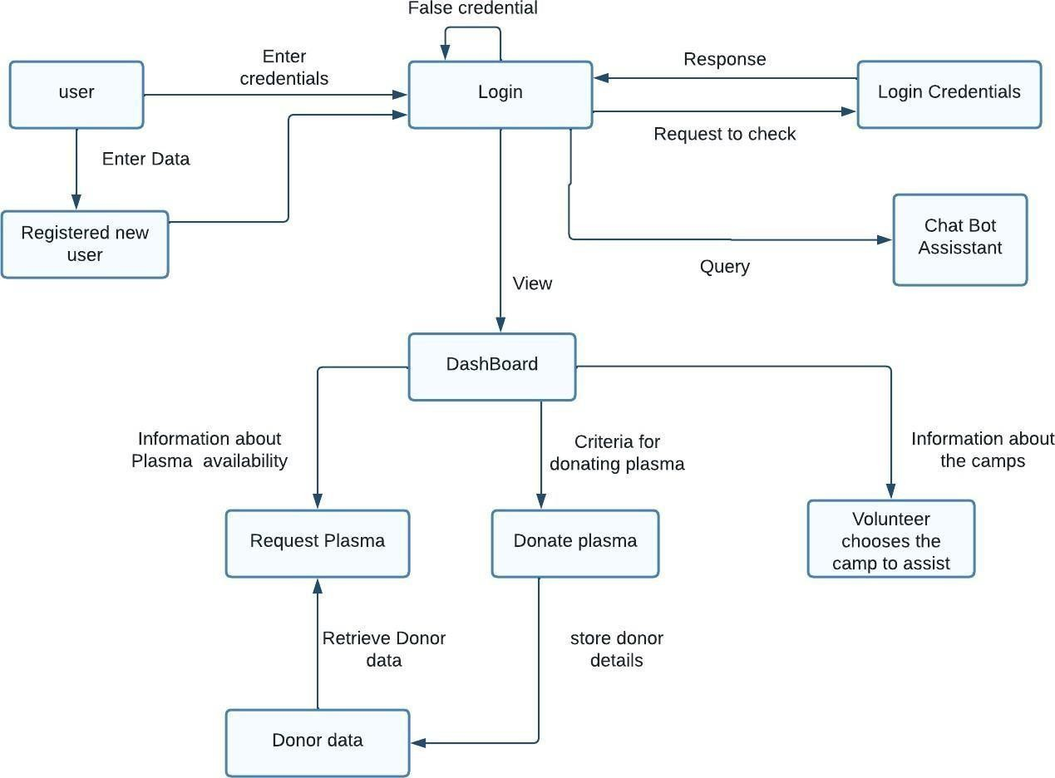

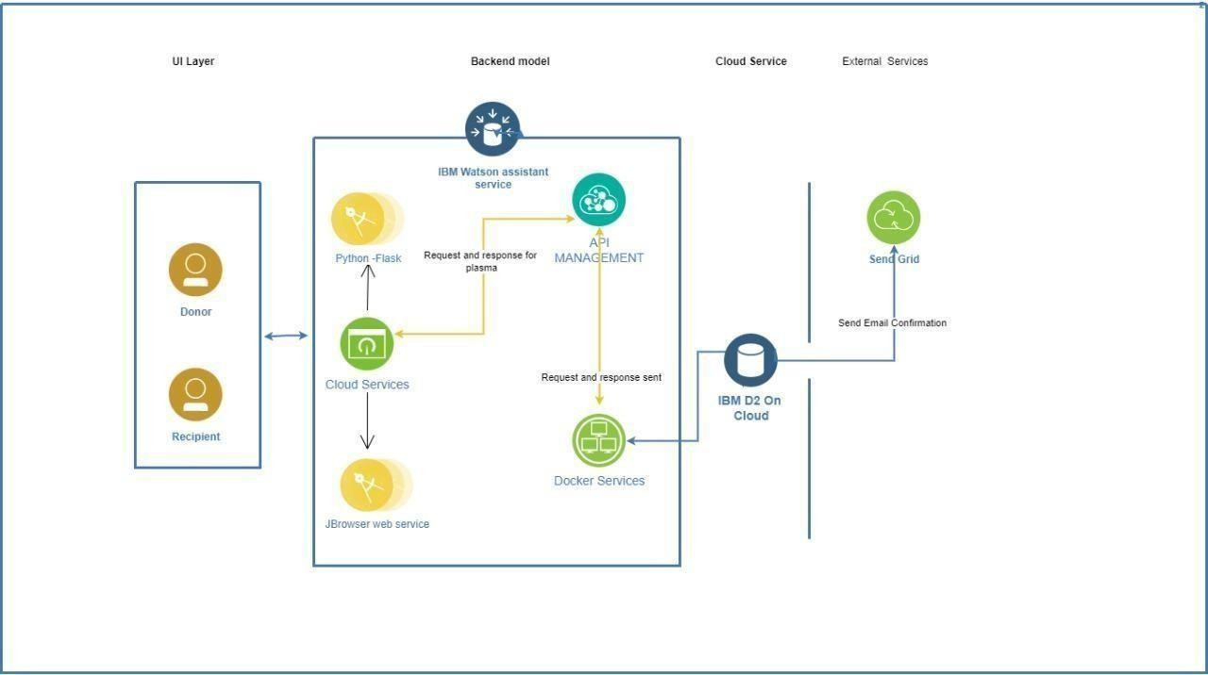

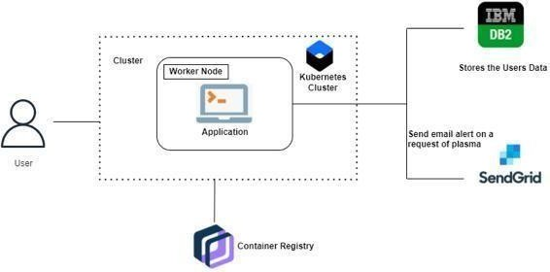

# Solution & Technical Architecture

Table-1 : Components & Technologies:

|  |  |  |  |
| --- | --- | --- | --- |
| **S.No** | **Component** | **Description** | **Technology** |
| 1. | User Interface | * The user creates an account or registers in the UI. * Goes through the UI and view details | HTML, CSS,Python Flask |
| 2. | Chatbot | * Used to clarify user queries | IBM Watson Assistant |
| 3. | Data maintenance | For storing,maintaining,modifying and retrieving  the user’s details | MySQL |
| 4. | Confirmation Email | Sending a confirmation email to users they have  registered for donation and to check the availability of plasma | SendGrid |
| 5. | Cloud Database | For storing the appointment ,donation details and  user’s details | IBM DB2 |
| 6. | File Storage | File storage requirements | IBM Block Storage |
| 7. | Infrastructure (Server / Cloud) | To deploy an Application on Local System | Kubernetes |

Table-2: Application Characteristics:

|  |  |  |  |
| --- | --- | --- | --- |
| **S.No** | **Characteristics** | **Description** | **Technology** |
| 1. | Open-Source Frameworks | Python flask micro framework is used. | Python Flask |
| 2. | Security Implementations | Mandatory Control(MAC) and Kubernetes is used. | SHA-256, Encryptions, IAM Controls, OWASP ,Kubernetes |
| 3. | Scalable Architecture | 3-Tier architecture is used. | Web Server-HTML,CSS Application Server-Python Flask Database Server-IBM DB2 |

|  |  |  |  |
| --- | --- | --- | --- |
| 4. | Availability | Using Load Balancer to distribute network traffic across servers. | IBM Load Balancer |
| 5. | Performance | Request and respond facility within a second. User-friendly API | IBM Content Delivery Network |

## 5.3.User Stories

Use the below template to list all the user stories for the product.

|  |  |  |  |  |  |  |
| --- | --- | --- | --- | --- | --- | --- |
| **User Type** | **Functional Requirement**  **(Epic)** | **User Story Number** | **User Story / Task** | **Acceptance criteria** | **Priority** | **Release** |
| Customer (Mobile user) | Registration | USN-1 | As a user, I can register for the application by entering my email, password, and confirming  my password. | I can access my account / dashboard | High | Sprint-1 |
|  |  | USN-2 | As a user, I will receive confirmation email  once I have registered for the application | I can receive confirmation  email & click confirm | High | Sprint-1 |
|  |  | USN-3 | As a user, I can register for the application  through Gmail | I can receive confirmation  notifications through Gmail | Medium | Sprint-1 |
|  | Login | USN-4 | As a user, I can log into the application by entering email & password | I can access into my User profile and view details in  dashboard | High | Sprint-1 |
|  | Dashboard | USN-5 | As a user,I can send the proper requests to  donate and obtain plasma. | I can receive appropriate  notifications through email | High | Sprint-1 |
| Customer (Web user) | Login | USN-6 | As a user,I can register and log into the application by entering email & password to  view the profile | I can access into my User profile and view details in  dashboard | High | Sprint-1 |
|  | Dashboard | USN-7 | As a user,I can send the proper requests to  donate and obtain plasma. | I can receive appropriate  notifications through email | High | Sprint-1 |
| Customer Care Executive | Application | USN-8 | As a customer care executive,I can try to address user’s concerns and questions | I can view and address their concerns and  questions | Medium | Sprint-2 |
| Administrator | Application | USN-9 | As an administrator I can help with user-facing aspects of a website, like its appearance, navigation and use of media. | I can  change the appearance  and navigation  in a user friendly manner | Medium | Sprint-3 |
|  |  | USN-10 | As an administrator, I can involve working with the technical side of websites. | I can help with such as troubleshooting issues, setting up web hosts, ensuring users have access and programming servers | Medium | Sprint-1 |

# PROJECT PLANNING & SCHEDULING

## Sprint Planning & Estimation

|  |  |  |  |  |  |  |
| --- | --- | --- | --- | --- | --- | --- |
| **Sprint** | **Functional Requiremen t**  **(Epic)** | **User Story Number** | **User Story / Task** | **Sto ry poi nts** | **Pri orit y** | **Team Members** |
| Sprint 1 | User Registration | USN-1 | As a user,I can register for the application by entering my email password confirming my password and phone number.. | 10 | Hi gh | Ponni P Madhumitha D Priscilla Amalraj, Mohanapriya BS Leny Fashitha |

|  |  |  |  |  |  |  |
| --- | --- | --- | --- | --- | --- | --- |
| Sprint 1 | User Login | USN-2 | As a user, I can log into the application by entering username & password. | 10 | Hi gh | Ponni P Madhumitha D Priscilla Amalraj, Mohanapriya BS Leny Fashitha |
| Sprint 1 | Access Website | USN-3 | User should be able to access application using browser | 10 | Hi gh | Ponni P Madhumitha D Priscilla Amalraj, Mohanapriya BS Leny Fashitha |
| Sprint 2 | Dashboard | USN-4 | The user upon logging in views the application dashboard where he/she can use all the application’s services. | 10 | Hi gh | Ponni P Madhumitha D Priscilla Amalraj, Mohanapriya BS Leny Fashitha |
| Sprint 2 | Request For Blood plasma | USN-5 | The user who is in need of blood plasma can request for blood b specifying the blood type. | 20 | Hi gh | Ponni P Madhumitha D Priscilla Amalraj, Mohanapriya BS Leny Fashitha |

|  |  |  |  |  |  |  |
| --- | --- | --- | --- | --- | --- | --- |
| Sprint 2 | Switch User Roles | USN-6 | As a user, he/she can switch roles between Donor and Receiver. | 20 | High | Ponni P Madhumitha D Priscilla Amalraj, Mohanapriya BS Leny Fashitha |
| Sprint 3 | View Plasma Request | USN-7 | A donor receives an Email of about the receiver’s details of the same blood type. | 20 | High | Ponni P Madhumitha D Priscilla Amalraj, Mohanapriya BS Leny Fashitha |
| Sprint 3 | View Donor Details | USN-8 | The receiver can view the list of Donors of the blood type requested. | 10 | High | Ponni P Madhumitha D Priscilla Amalraj, Mohanapriya BS Leny Fashitha |
| Sprint 4 | Logout Process | USN-9 | The User will be able to Logout of the application. | 10 | High | Ponni P Madhumitha D Priscilla Amalraj, Mohanapriya BS Leny Fashitha |
| Sprint 4 | Bot service in the website | USN-10 | The user can use Bot Service to request for Blood Plasma and also switch between roles. | 10 | High | Ponni P Madhumitha D Priscilla Amalraj, Mohanapriya BS Leny Fashitha |

**6.2.Sprint Delivery Schedule**

|  |  |  |  |  |  |
| --- | --- | --- | --- | --- | --- |
| **Sprint** | **Total Story**  **Points** | **Duration** | **Sprint Start Date** | **Sprint End Date (Planned)** | **Sprint Release Date (Actual)** |
| Sprint-1 | 30 | 6 Days | 25 Oct 2022 | 30 Oct 2022 | 30 Oct  2022 |
| Sprint-2 | 30 | 6 Days | 1 Nov 2022 | 6 Nov 2022 | 6 Nov  2022 |

|  |  |  |  |  |  |
| --- | --- | --- | --- | --- | --- |
| Sprint-3 | 30 | 6 Days | 8 Nov 2022 | 13 Nov 2022 | 13 Nov  2022 |
| Sprint-4 | 30 | 5 Days | 14Nov 2022 | 18 Nov 2022 | 18 Nov  2022 |

# CODING & SOLUTIONING

* 1. **FEATURE 1** [**https://github.com/IBM-EPBL/IBM-Project-28334-**](https://github.com/IBM-EPBL/IBM-Project-28334-1660110795/tree/main/Ponni%20P/Project%20Development%20Phase/Sprint-1)[**1660110795/tree/main/Ponni%20P/Project%20Development%20Phase/Sprint-1**](https://github.com/IBM-EPBL/IBM-Project-28334-1660110795/tree/main/Ponni%20P/Project%20Development%20Phase/Sprint-1)

It consists of two modules landing and sign up Landing- it is a main web page of our model

Sign up-In this module, users can register their name as a donor. If a certain age limit is satisfied their registration process for plasma donors will be accepted.

* 1. **FEATURE 2** [**https://github.com/IBM-EPBL/IBM-Project-28334-**](https://github.com/IBM-EPBL/IBM-Project-28334-1660110795/tree/main/Ponni%20P/Project%20Development%20Phase/Sprint-2)[**1660110795/tree/main/Ponni%20P/Project%20Development%20Phase/Sprint-2**](https://github.com/IBM-EPBL/IBM-Project-28334-1660110795/tree/main/Ponni%20P/Project%20Development%20Phase/Sprint-2)Login- Here we discussed about login module,

In this module, users can login as a donor and they can update their availability status.

Dashboard-In this module we discussed about dashboards which shows all the available donors and other resources of web page

* 1. **FEATURE 3** [**https://github.com/IBM-EPBL/IBM-Project-28334-**](https://github.com/IBM-EPBL/IBM-Project-28334-1660110795/tree/main/Ponni%20P/Project%20Development%20Phase/Sprint-3)[**1660110795/tree/main/Ponni%20P/Project%20Development%20Phase/Sprint-3**](https://github.com/IBM-EPBL/IBM-Project-28334-1660110795/tree/main/Ponni%20P/Project%20Development%20Phase/Sprint-3)

Chatbot- in this module Chatbot is created which helps the user to know more about plasma donation.

* 1. **FEATURE** [**https://github.com/IBM-EPBL/IBM-Project-28334-**](https://github.com/IBM-EPBL/IBM-Project-28334-1660110795/tree/main/Ponni%20P/Project%20Development%20Phase/Sprint-4)[**1660110795/tree/main/Ponni%20P/Project%20Development%20Phase/Sprint-4**](https://github.com/IBM-EPBL/IBM-Project-28334-1660110795/tree/main/Ponni%20P/Project%20Development%20Phase/Sprint-4)

In this process we make a database connectivity for register , login and update of donor information, and also contains the the image with help of using docker.

## TEST CASES

**8.1.CHATBOT WORKING**

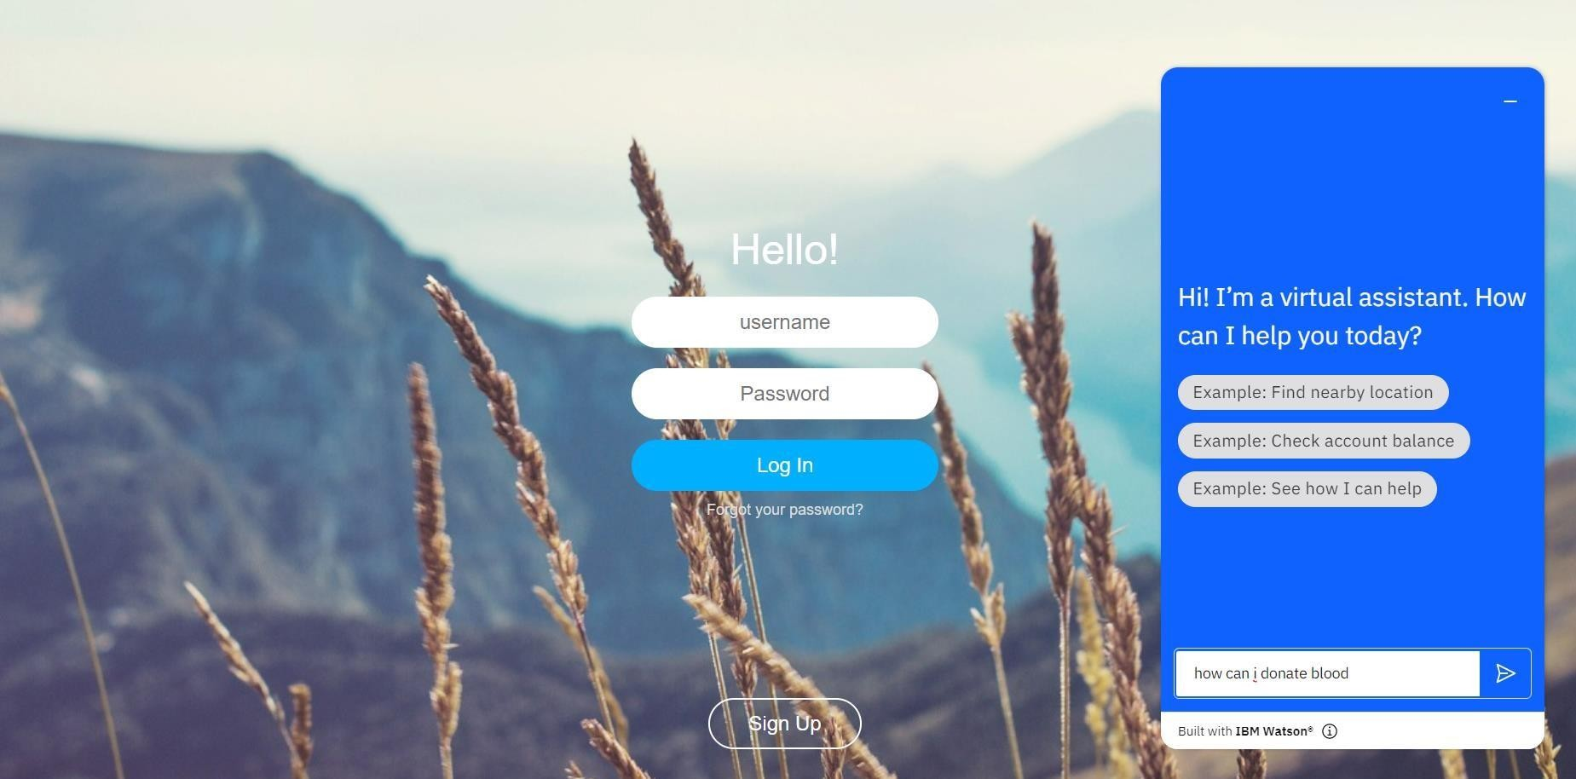

# 8.2 DONOR REGISTRATION

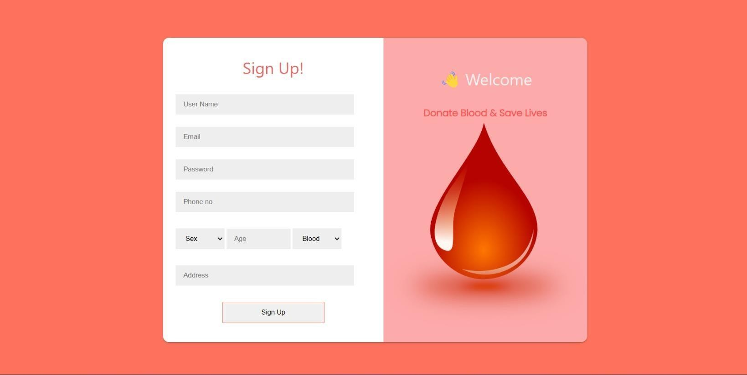

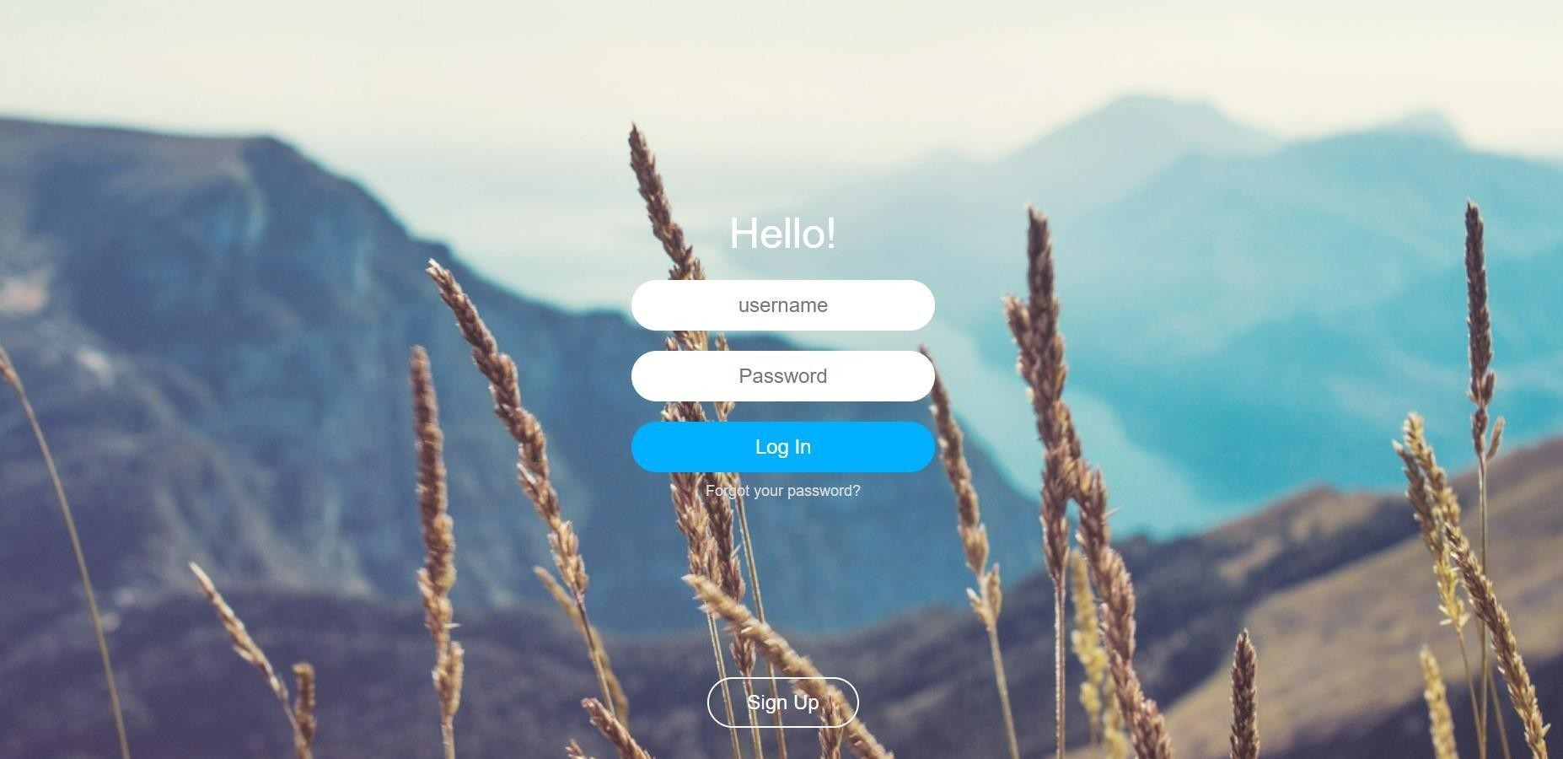

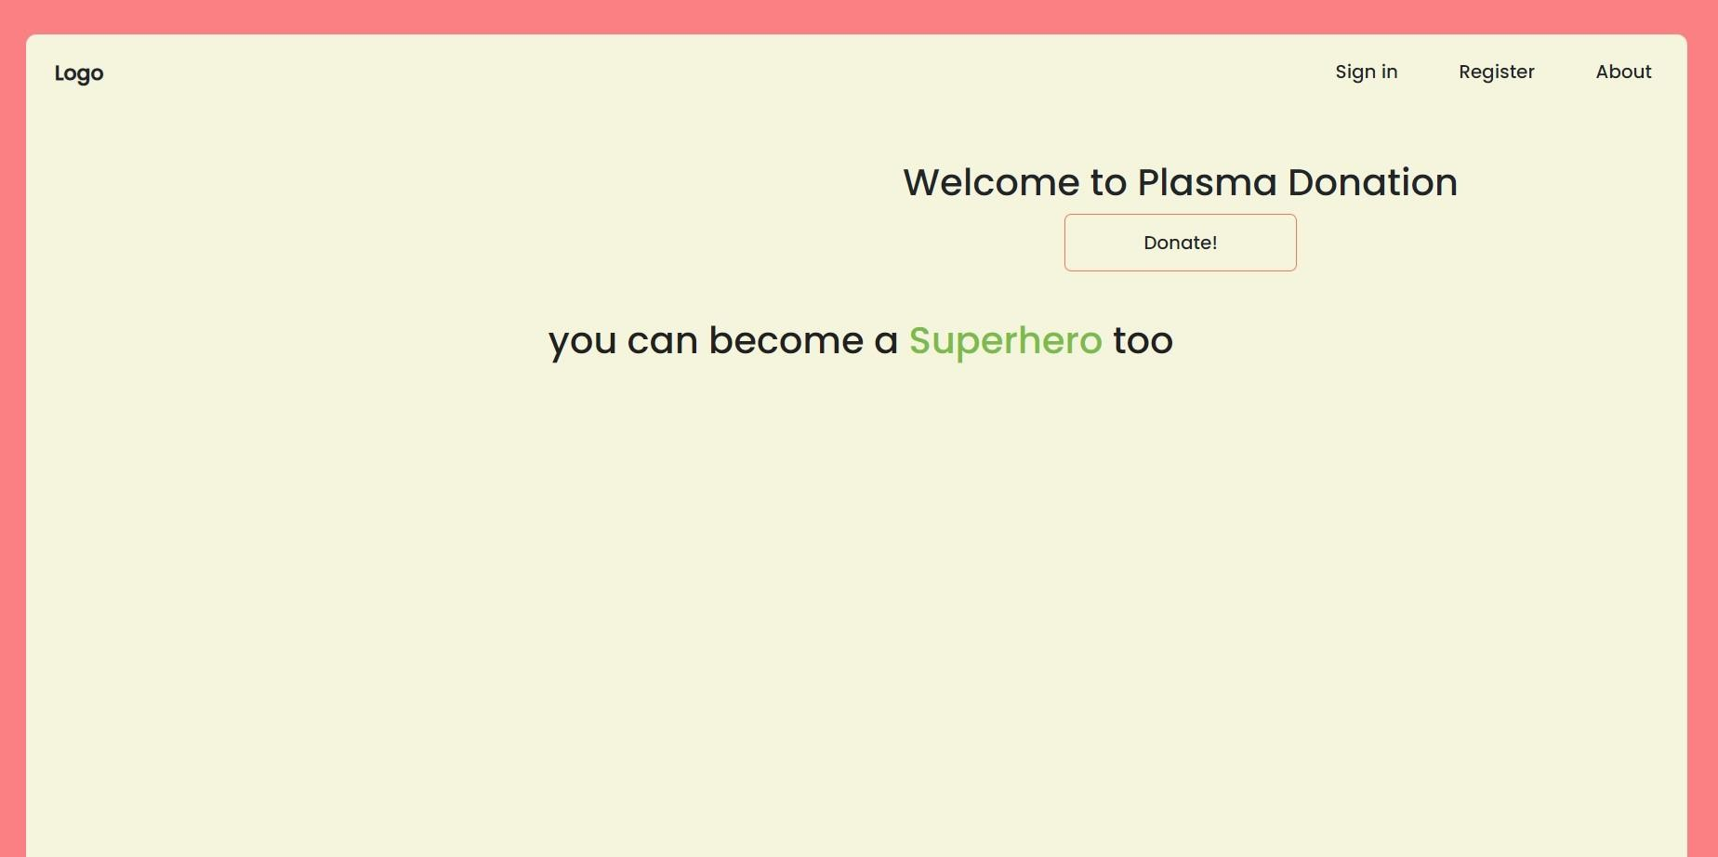

**8.3.DONOR LOGIN**

## 8.4 DONOR ADDER

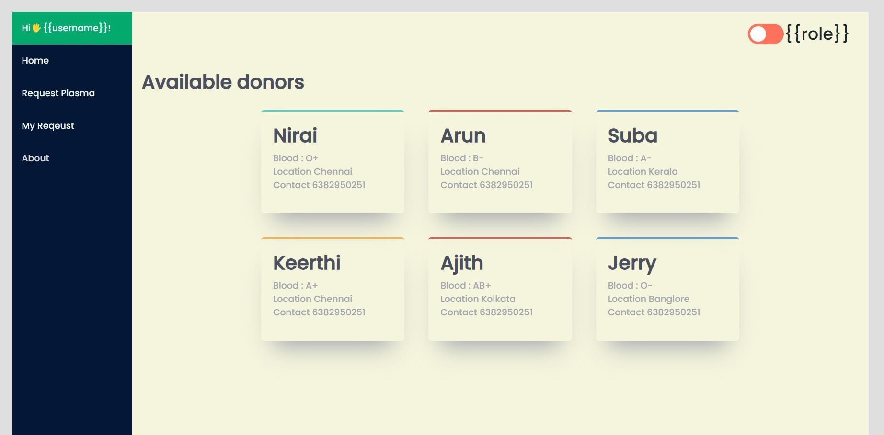

1. **RESULT**

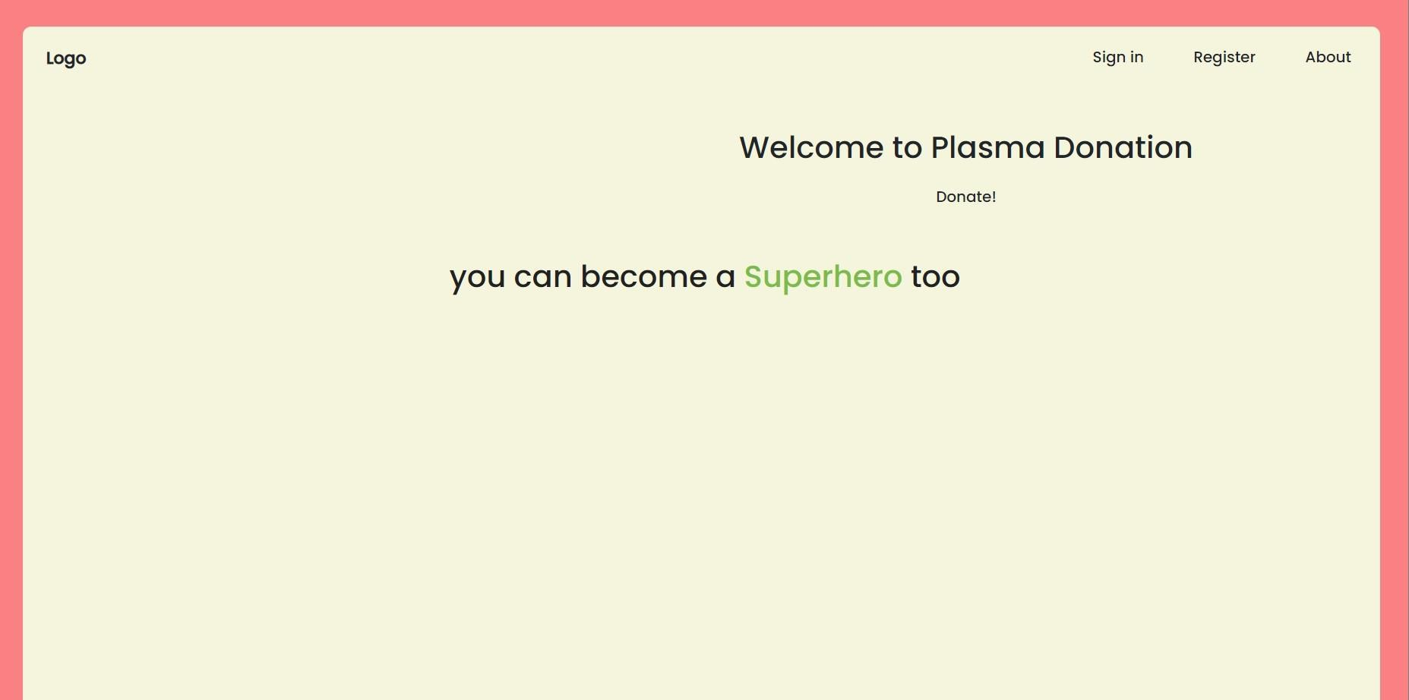





**.**

# ADVANTAGE & DISADVANTAGE

* Easy connecting donors and recipients makes plasma donation way more proficient.
* Prime motive of the app is to solve the perpetual shortfall of plamsa donors.
* It connects plasma donors and recipients through a single and scalable platform.
* Effortless access: Users on this platform will be able to use the app with just one-click.

# CONCLUSION

The efficient way of finding plasma donors for the infected people is implemented using the plasma donor website that is hosted on Cloud platform. To ensure the smooth functioning of the website operations. I have hosted the website on a cloud platform to make sure the operations service are running successfully to deploy the application cloud.

# FUTURE ENHANCEMENTS

Upgrading the UI that is more user-friendly which will help many users to access the website and also ensures that many plasma donors can be added into the community. Using elastic load balancer, it helps to handle multiple requests at the same time which will maintain the uptime of the website with negligible downtime.

# FUTURE ENHANCEMENTS

Upgrading the UI that is more user-friendly which will help many users to access the website and also ensures that many plasma donors can be added into the community. Using elastic load balancer, it helps to handle multiple requests at the same time which will maintain the uptime of the website with negligible downtime.

# APPENDIX GITHUB LINK:

**https://github.com/IBM-EPBL/IBM-Project-28334-1660110795**

# DEMO LINK:

# https://youtu.be/6Y3Nybb7vys